**1. INTRODUCTION**

**1.1 METHODOLOGY**

The software process model used in our website is ”Incremental model”. Incremental model is an evolution of waterfall model. The product is designed, implemented, integrated and tested as a series of incremental builds. It is a popular model software evolution used many commercial software companies and system vendor.

The incremental model has following phases:

* Analysis
* Design
* Code
* Test

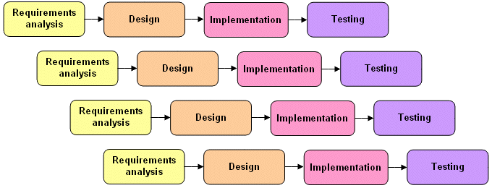

**Analysis:-**

Requirements are gathered in this phase. In this phase the main focus of the project is on the managers and stake holders. Meetings with managers, stake holders and users are held in order to determine the requirements like who is going to use the system, how will they use the system, what data should be input into the system and what data should be output by the system. These are general questions that get answered during a requirements gathering phase. After requirement gathering these requirements are analyzed for their validity and the possibility of incorporating the requirements in the system to be development is also studied.

**Design:-**

In this phase the system and software design is prepared from the requirement specifications which were studied in the first phase. System Design helps in specifying hardware and system requirements and also helps in defining overall system architecture. The system design specifications serve as input for the next phase of the model.

**Code:-**

On receiving system design documents, the work is divided in modules/units and actual coding is started. Since, in this phase the code is produced so it is the main focus for the developer.

**Test:-**

After the code is developed it is tested against the requirements to make sure that the product is actually solving the needs addressed and gathered during the requirements phase.

**1.2 PURPOSE**

The purpose of this project is designing a platform where all material related to subject is available at a single place. So everyone will be able to access the good and concrete content in a efficient manner and it also saves the time. Everyone now has a smartphone and use internet facilities so it is high-tech and mobile access is also there. Also an individual does not have to purchase books so it is affordable as well.

**1.3 SCOPE**

* There are three basic users – **Student ,faculty, admin.**
* All users have their own profiles in E-learning.
* The interaction between students and faculty.
* Students can register here and then login to be able to access the content related to CS & IT and also programming languages. They can also upload course related content and can also write their queries.
* Faculty can upload course related content and will solve queries of students.
* Admin has the authority to add/delete users, grant permission to students and faculty to upload content. He also views the queries of students and will solve them.

**1.4 DESCRIPTION, ACRONYMS AND ABBREVIATION**

**Admin**

**Administrator**  He has the authority to add/delete users, grant permission to students and faculty to upload content.

**JSP**

**Java Server Pages.** It is used to create dynamic web content**.**

**HTML**

**Hypertext Markup Language.** It is used to create web pages.

**UML**

**Unified Modeling Language** is a standard language for writing software blueprints. The

UML may be used to visualize, specify, construct and document

**CSS**

**Cascading Stylesheet** is used to design web pages.

**1.5 TOOLS USED**

* **Database:** My SQL
* **IDE:** Netbeans
* **WebServer:** Apache Tomcat
* **Designing Tool:** Rational Rose Modeler
* **Language:** Java

**1.6 REFERENCES**

* Object Oriented Modeling and Design with UML-Michael Blaha, James Rambaugh.
* Software Engineering, Seventh Edition, Ian Sommerville.
* IBM Red Books.
* IBM TGMC Sample Synopsis.
* IBM – www.ibm.in/developerworks .
* Java - www.sun.com
* Wikipedia - www.wikipedia.com
* Database Management Systems - Navathe.

**1.7 TECHNOLOGIES TO BE USED**

* **Languages:** Java, Html, css, Javascript
* **Database:** My SQL
* **IDE:** Netbeans
* **WebServer:** Apache Tomcat
* **Designing Tool:** Rational Rose Modeler.

**1.8 OVERVIEW**

Nowadays people are busy as a beavers there is increasing need of E-Learning. It is helpful in various cases:

* Extension of academic institution:-Any institute can use this kind of application so that students can get the academic information as well as course content online.
* The website is available 24 hours a day and any person can access it.
* Educational organizations such as coaching centers seek to offer online E-Learning to reduce cost of infrastructure and provide remote access to students.

**2.0 OVERALL DESCRIPTION**

**2.1 PRODUCT PERSPECTIVE**

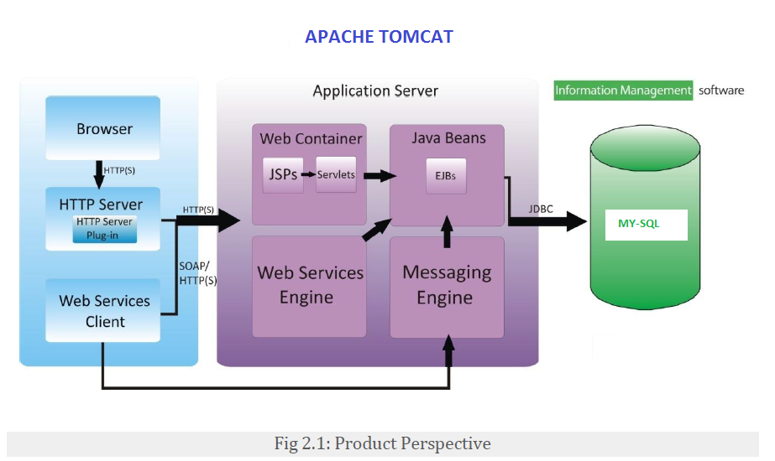

**2.2 SOFTWARE INTERFACE**

Operating System : Windows

Technology : Java

Web Technologies : Html, JavaScript, CSS

IDE : NetBeans

WebServer : Apache Tomcat

Database : My SQL

Java Version : J2SDK1.5

**2.3 HARDWARE INTERFACE**

Processor – Pentium

Speed – 1.1GHz

RAM – 256

HardDisk – 10GB

KeyBoard – Standard Windows Keyboard

Mouse – Two or Three Button Mouse

Monitor - SVGA

**2.4** **COMMUNICATION INTERFACE**

* Client (user) on internet will be using HTTP protocols.
* Client can interact with Web-browser (internet explorer 8 or above, Firefox 5 or above can be used).

**2.5** **CONSTRAINTS**

* GUI is only in English.
* Only approved faculty or admin can upload study material directly.
* Only registered user can submit content for approval.
* Registration and login required for downloading study material.
* Only http protocol is used to deliver content.

2.7 **USE CASE MODEL SURVEY**

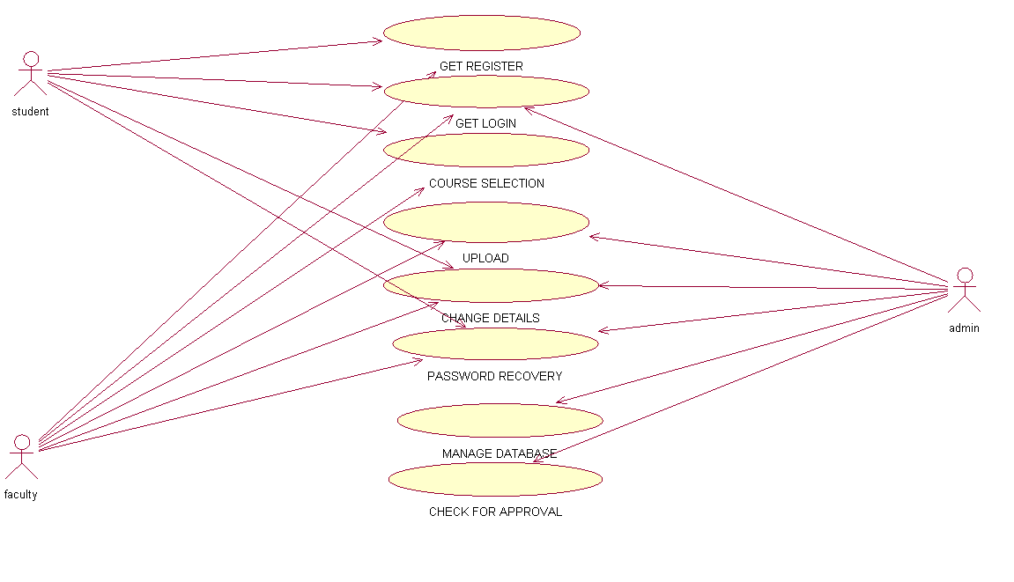

2.8**ARCHITECTURE**